Instructions for Extended Abstract Preparation for the ISMB18 2023 in Lyon
First name LAST NAME ª, First name LAST NAME ^{b}, First name LAST NAME ª
a First Affiliation, First Street 201, 4040 First City, First Country, first.email@mail.com (specify for at least one author)
b Second Affiliation, Second Street 201, 39501 Second City, Second Country

1. Introduction
Please prepare your extended abstract in the pdf format using this format. The length of the extended abstract is limited to two A4 (21 x 29.7 cm) pages.

2. Manuscript formatting
When preparing the extended abstract for your paper, please make sure that the main idea of your publication is clearly described. If there are still some parts missing, point them out in an outlook so your reviewers can grasp the full extent or your investigations. Extended abstracts should not include a separate abstract.

3. Figures, equations and references
You are invited to use graphs, images, photos, tables, equations, etc. to clarify your ideas. Sometimes, a picture is worth a thousand words. .Sometimes, a picture is worth a thousand words. Feel free to use colored images but please make sure that the image can be correctly understood when printed in black and white! Always use references when you insert an image like Fig. 1 or a table like Table I or if you want to direct the reader to an equation like (1). The International System of Units (SI units) should be used throughout the manuscript.
(1)

Table 1 Use tables for a clear overview of your data
 | Parameter | Value
dr | Outer rotor diameter | 150 mm
S | Current density | 20 A/mm2
P | Rated power | 500 W

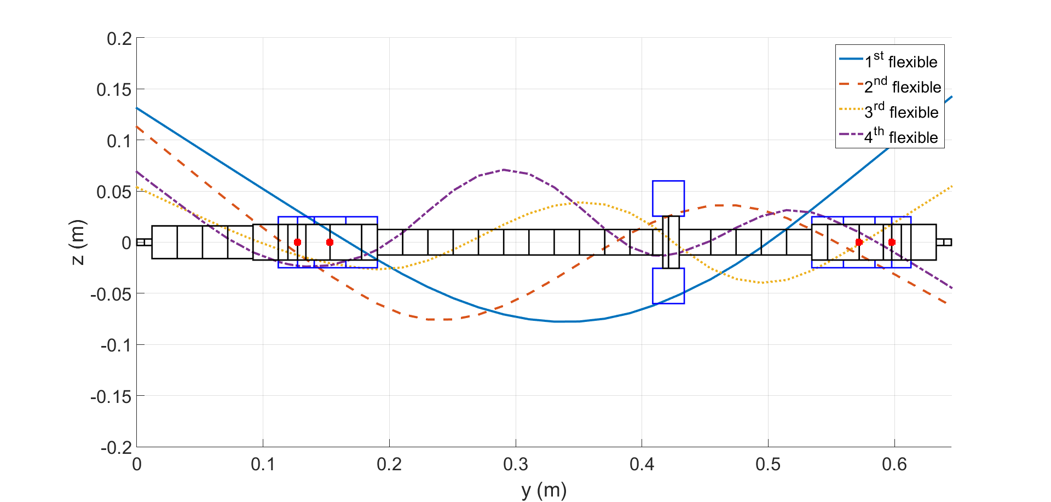

Figure 1 Make sure your images have labels for the axes including the allied unit. Please ensure that your figures have sufficient resolution so that the text is readable.

4. Submission
After you complete your paper, convert it to Adobe Portable Document Format (PDF). The PDF file size should not exceed 6 MByte. Your abstract can be uploaded on the abstract page of the ISMB18 site:
http:// www.ismb18.org/
The deadline for the extended abstracts is January 06, 2023. The notifications of acceptance will be sent on February 13, 2023.

References (if necessary)

Should be based on the SAGE Harvard guidelines:
Citations in the text are indicated by author’s last name and year with the list of references arranged in alphabetic order: for example, (Ahrendt and Taplin, 1951) or the book by Ahrendt and Taplin (1951). For a reference from three or more authors, the citation in the text is indicated by the first author's name followed by "et al." and the year: for example, (Takeuchi, et al., 2006). More than one reference from the same author(s) in the same year are identified by the letters "a", "b", "c", placed after the year: for example, (Karin and Hanamura, 2010a, 2010b). Unpublished works (including papers not yet submitted or not yet published) should be avoided. The complete name of the journal referred to should be given. Cite references published as recently as possible.

Book
Clark JM and Hockey L (1979) Research for Nursing. Leeds: Dobson Publishers.
Book chapter
Gumley V (1988) Skin cancers. In: Tschudin V and Brown EB (eds) Nursing the Patient with Cancer. London: Hall House, pp.26–52.
Journal article
Huth EJ, King K and Lock S (1988) Uniform requirements for manuscripts submitted to biomedical journals. British Medical Journal 296(4): 401–405.
Website
National Center for Professional Certification (2002) Factors affecting organizational climate and retention. Available at: www.cwla.org./programmes/triechmann/2002fbwfiles (accessed 10 July 2010).
Thesis/dissertation
Clark JM (2001) Referencing style for journals. PhD Thesis, University of Leicester, UK.
Conference article (published or unpublished)
Clark JM and Smith P (2002) Latest research on car exhaust manifolds. In: 17th international conference on strain analysis (ed L Macadam), London, UK, 23–25 September 2010, pp.12–14. London: Professional Engineering Publishing.
Report
MacDonald S (2008) The state of social welfare in the UK. Report, University of Durham, UK, June.
Standard
ISO 27799:2008 (2008) Information security management in health.

Please feel free to use footnotes if you need.

